TGA测试_TGA检测_热重分析
仪器型号： 美国TA Q500
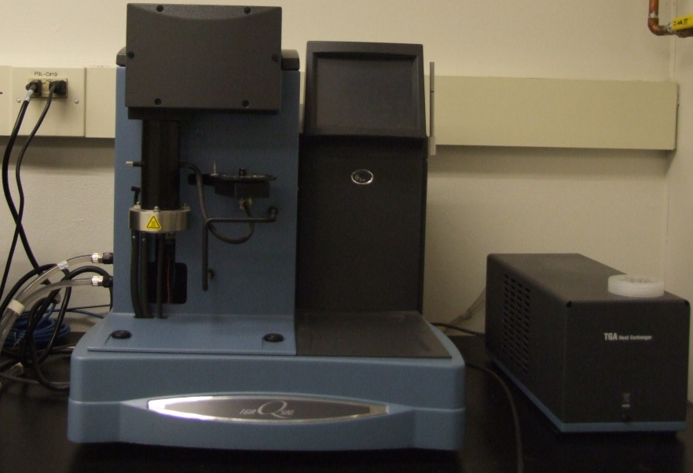
原理
在程序温度控制下测量物质质量随温度变化的一种技术
仪器技术参数
温度范围 ：室温～1000℃
温度精确度 ：± 0.1℃
升温速率：0.1～100℃/min
送样要求
0.5-1.0g，液体或者固体。样品在测试温度范围内不爆炸，不产生剧毒的气体。
应用领域
可用于分析熔化、蒸发、升华和吸附等物质的物理现象；研究物质的热稳定性、分解过程、脱水、解离、添加剂与填充剂影响、水份与挥发物。
常见适用标准
ASTM E2550-07，ASTM D6370-99(2009)，GB/T 14837-93，IPC-TM-650 2.4.24.6-06，ISO 11358-1997。
专业、高效、精准、高性价比是剂拓公司的服务宗旨。

联系电话：021-20423181
联系人：周工18321012245；张工18321432694
QQ：2312070180
企业微博：http://weibo.com/jituotech
企业博客：http://jituotech.blog.163.com/
邮箱地址：jituotech@jituotech.com
公司网址：www.jituotech.com

Thermogravimetric Analysis (TGA) ASTM E1131, ISO 11358

Compositional Analysis by TGA - ASTM E1131, ISO 11358
Scope:
Thermogravimetric Analysis measures the percent weight loss of a test sample while the sample is heated at a uniform rate in an appropriate environment. The loss in weight over specific temperature ranges provides an indication of the composition of the sample, including volatiles and inert filler, as well as indications of thermal stability
Test Procedure:
Set the inert (usually N2) and oxidative (O2) gas flow rates to provide the appropriate environments for the test. Place the test material in the specimen holder and raise the furnace. Set the initial weight reading to 100%, then initiate the heating program. The gas environment is preselected for either a thermal decomposition (inert - nitrogen gas), an oxidative decomposition (air or oxygen), or a thermal-oxidative combination.
Specimen size:
10 to 15 milligrams
Data:
A plot of percent weight loss versus temperature.
**Please note that this test description is intentionally generic in nature and aimed at providing a descriptive summary to enhance test understanding. Standards can be obtained from appropriate standard authorities.
- Testlopedia - The Plastics Testing Encyclopedia
- Ash Content ASTM D2584, D5630, ISO 3451
- Volatiles Content of Composite Prepreg ASTM D3530
- Void Content of Reinforced Plastics ASTM D2734
Request more information to see how Intertek can help your organization with Thermogravimetric Analysis (TGA) ASTM E1131, ISO 11358.

