DSC测试_DSC检测_差示扫描量热仪_服务
仪器型号： 美国TA Q2000
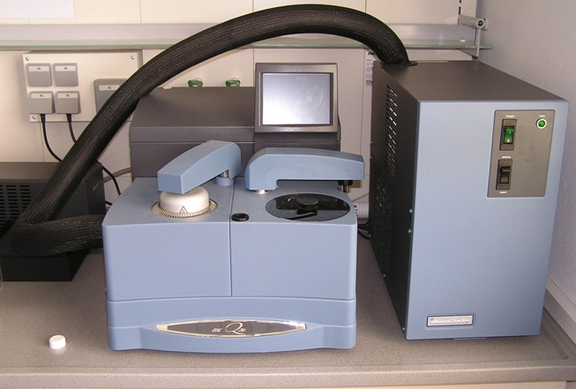
原理
差示扫描量热法(DSC)是在程序控制温度下,测量输给物质和参比物的功率差与温度关系的一种技术。
仪器技术参数
温度范围 ：-75～550℃
温度精确度 ：± 0.01℃
升温速率：0.1～100℃/min
送样要求
0.5-1.0g，液体或者固体。样品在测试温度范围内不裂解，不爆炸，不挥发，不产生剧毒的气体。
应用领域
测试材料的玻璃化转变温度、冷结晶、比热容、相转变、熔融、结晶、产品稳定性、固化/交联、氧化诱导期等。
常见适用标准
氧化诱导期 ：ASTM D3895-07，ISO 11357-6:2008，GB/T 19466.6-2009
焓变：GB/T 19466.3-2004，ASTM D3418，ISO 11357-3:2011
玻璃化转变温度：ISO 11357-2，GB/T 19466.2-2004，ASTM D3418
熔点：ISO 11357-3，GB/T 19466.3，ASTM D3418。
专业、高效、精准、高性价比是剂拓公司的服务宗旨。

联系电话：021-20423181
联系人：周工18321012245；张工18321432694
QQ：2312070180
企业微博：http://weibo.com/jituotech
企业博客：http://jituotech.blog.163.com/
邮箱地址：jituotech@jituotech.com
公司网址：www.jituotech.com

DSC (Differential Scanning Calorimetry) analysis.
Differential scanning calorimetry (DSC) measures Specific Heat Capacity, Heat of Transition, and the Temperature of Phase Changes and Melting Points. DSC measures the rate of heat flow, and compares differences between the heat flow rate of the test sample and known reference materials. The difference determines variations in material composition, crystallinity and oxidation.
Differential scanning calorimetry thermal analysis provides test data for a wide range of materials. Materials analyzed by DSC include polymers, plastics, composites, laminates, adhesives, food, coatings, pharmaceuticals, organic materials, rubber, petroleum, chemicals, explosives, biological samples and more.
DSC thermal analysis:
- Thermal Phase Change
- Thermal Glass Transition Temperature (Tg)
- Crystalline Melt Temperature
- Endothermic Effects
- Exothermic Effects
- Thermal Stability
- Thermal Formulation Stability
- Oxidative Stability Studies
- Transition Phenomena
- Solid State Structure
- Analysis of a Diverse Range of Materials
DSC analysis determines:
- Tg Glass Transition Temperature
  - Temperature (°C) at which amorphous polymers or an amorphous part of a crystalline polymer go from a hard brittle state to a soft rubbery state

- Tm Melting point
  - Temperature (°C) at which a crystalline polymer melts

- Δ Hm Energy Absorbed (joules/gram)
  - Amount of energy a sample absorbs when melting

- Tc Crystallization Point
  - Temperature at which a polymer crystallizes upon heating or cooling

- Δ Hc Energy Released (joules/gram)
  - Amount of energy a sample releases when crystallizing
Intertek DSC instruments are equipped for rapid assessment of large sample batches. Calorimeters operate over a temperature range of -60C to 500C. Intertek laboratory scientists offer substantial expertise in the field of thermal analysis. Determination of endotherms, exotherms and weight loss on heating or cooling are performed.

Thermal Analysis:
- Thermal Analysis and Testing
- DSC Testing of Polymers and Plastics
- Glass Transition Temperature Test

